24ADI204 - Data Science & Visualization
Team Number: 18
Week-01 Report
Problem Definition & Data Setup
Project: House Price Analysis and Dashboard

1. Activity / Milestone
This week focused on defining the problem and preparing the working environment for the House Price Analysis project. The objective was to select a real-world housing dataset, load it into Python and confirm that the records are readable before any analysis begins.
Problem Statement: Buyers, sellers and agents find it difficult to understand which factors decide the price of a house, because raw sales data is large and contains missing and inconsistent values. This project cleans and analyses the data to find the main drivers of price (size, rooms and location) and presents them through an interactive Power BI dashboard.

2. Dataset Description
The dataset contains 4,675 house sale records from the Seattle area, Washington (USA), collected between May and July 2014. Each record has 18 attributes: sale date, price, bedrooms, bathrooms, living area, lot area, floors, waterfront, view, condition, above-ground area, basement area, year built, year renovated, street, city, zip code and country.

3. Data Source & Links
The housing dataset was taken from Kaggle and loaded into Google Colab as a CSV file using Pandas.
GITHUB REPOSITORY LINK:
https://github.com/wahith628-cmyk/Housing-
COLAB NOTEBOOK LINK:
https://colab.research.google.com/drive/1KAtVlM3go3ssdov3AtYui318LcVl_YK9
DATASET LINK (KAGGLE):
https://www.kaggle.com/datasets/ananthaselvane/housing-dataset
Metric | Value
Total Records | 4,675
Total Columns | 18
Sale Period | May to July 2014
Region | Seattle area, Washington (USA)

4. Code Implementation
Google Colab was used as the coding environment. The CSV file was uploaded, the Python libraries (Pandas, NumPy, Matplotlib, Seaborn) were imported and the data was read into a DataFrame. The first and last five records were displayed to verify the load.
CODE SCREENSHOT (Upload):
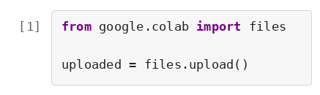
OUTPUT:
CODE SCREENSHOT (Import libraries and load data):
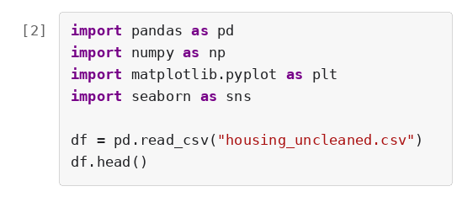
OUTPUT:
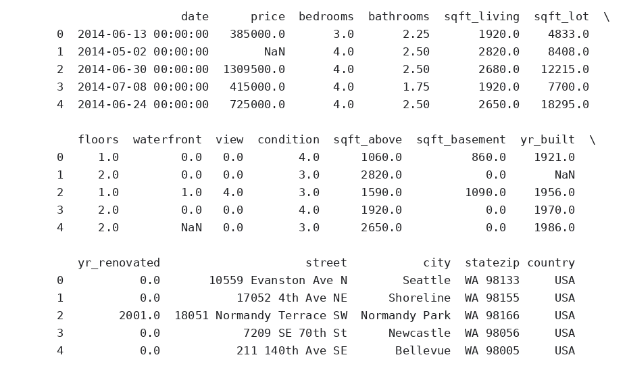
CODE SCREENSHOT (Last records):
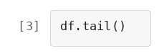
OUTPUT:
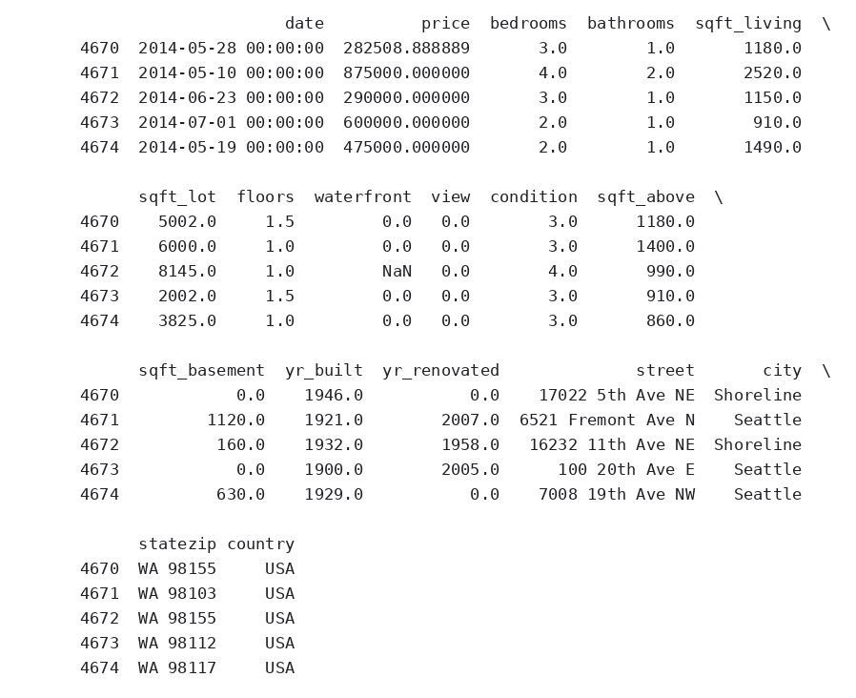

5. Screenshots & Error Handling
The first and last records were checked to make sure the file loaded completely and in the right format. Missing entries were already visible in these records (shown as NaN), so a detailed quality check was planned for Week 2.
Observations from the records:
- Row 2 of the dataset has no value in the price column (NaN).
- The last records include a missing waterfront value, so missing data is spread through the whole file.
- The last records belong to Seattle and Shoreline, both in Washington state (WA).
Key Insights:
- The dataset loaded successfully with 4,675 rows and 18 columns.
- It is a real, uncleaned dataset, so cleaning is required before analysis.
- Price, area and location columns are available to study what affects house price.

6. Team Contributions
Team Member | Working | Outcome
Inban S | Data Engineer | Selected the housing dataset from Kaggle, uploaded it to Colab and verified the data load
Abdul Wahith M | Data Analyst | Inspected the first and last records and noted the early data quality issues
Dharshan P | Visualization Expert | Planned the charts and Power BI dashboard layout for the coming weeks
Anantha Selvan E | Story Teller | Wrote the problem statement and prepared the Week 1 report

